1. Create MariaDB DB on EC2.

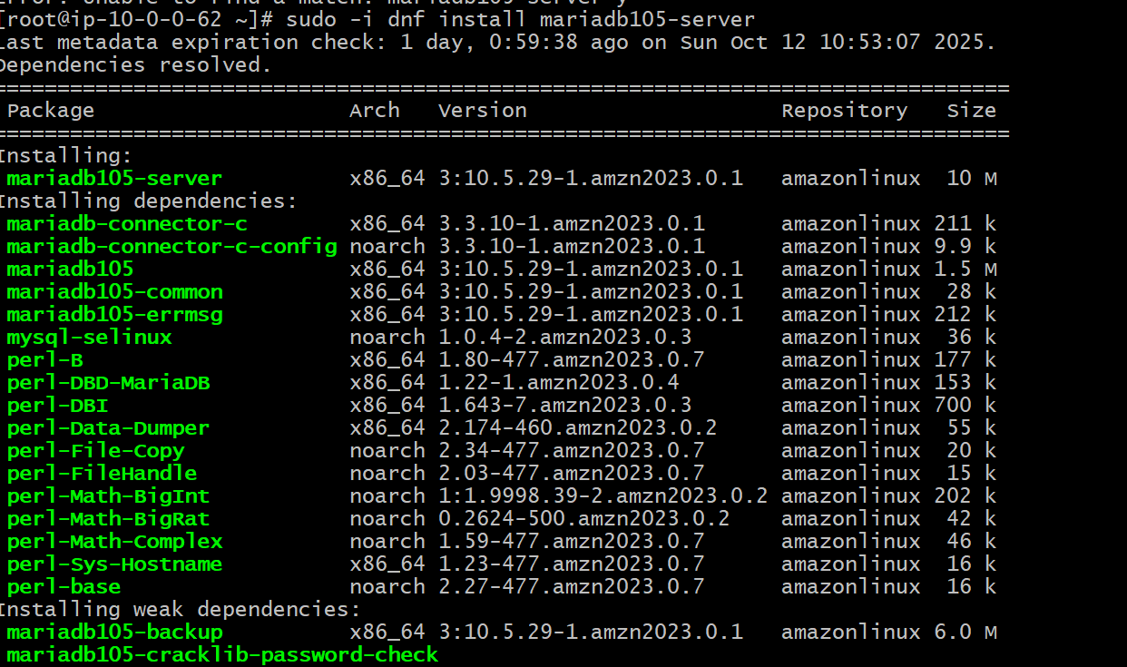

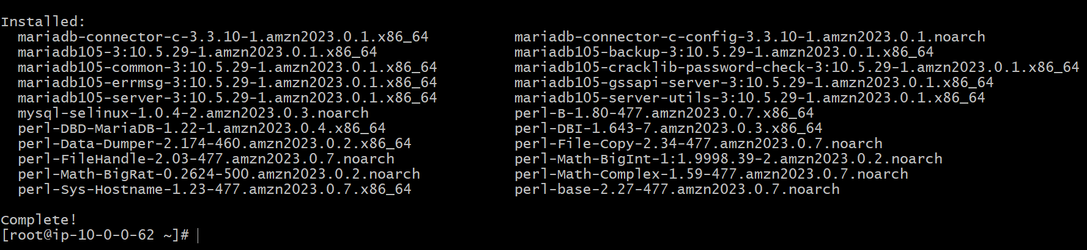

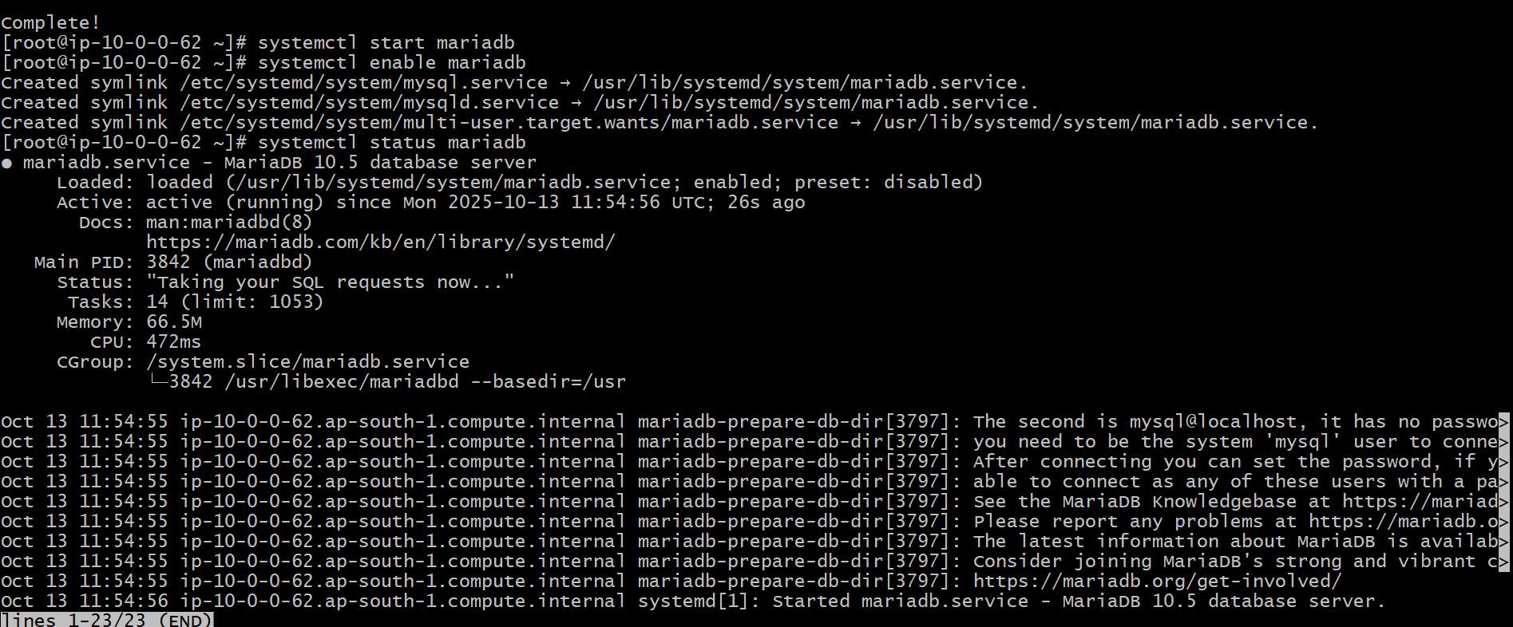

1. Insert some dummy data.

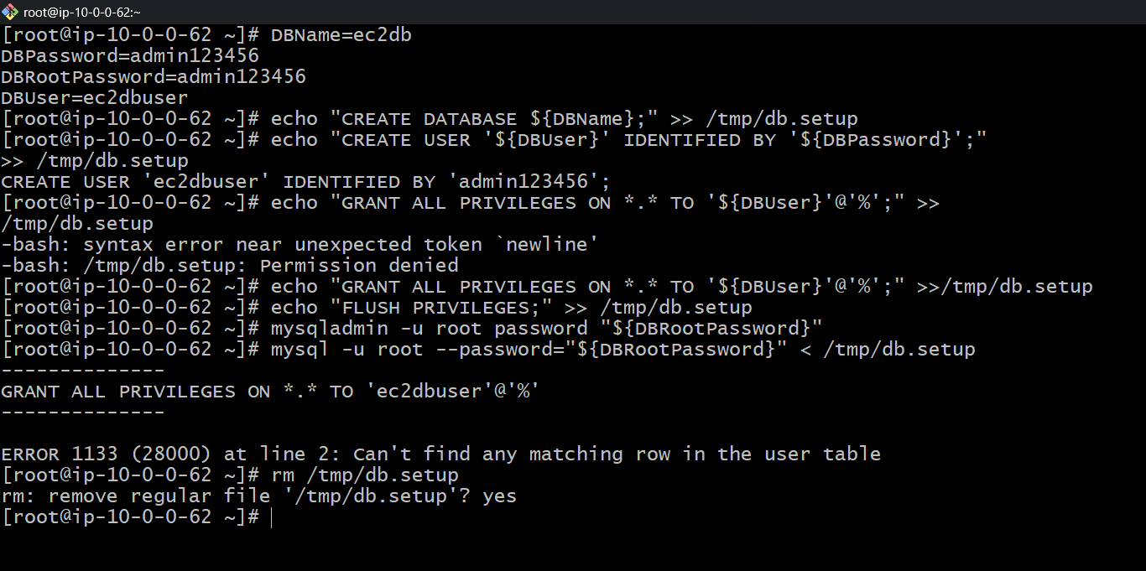

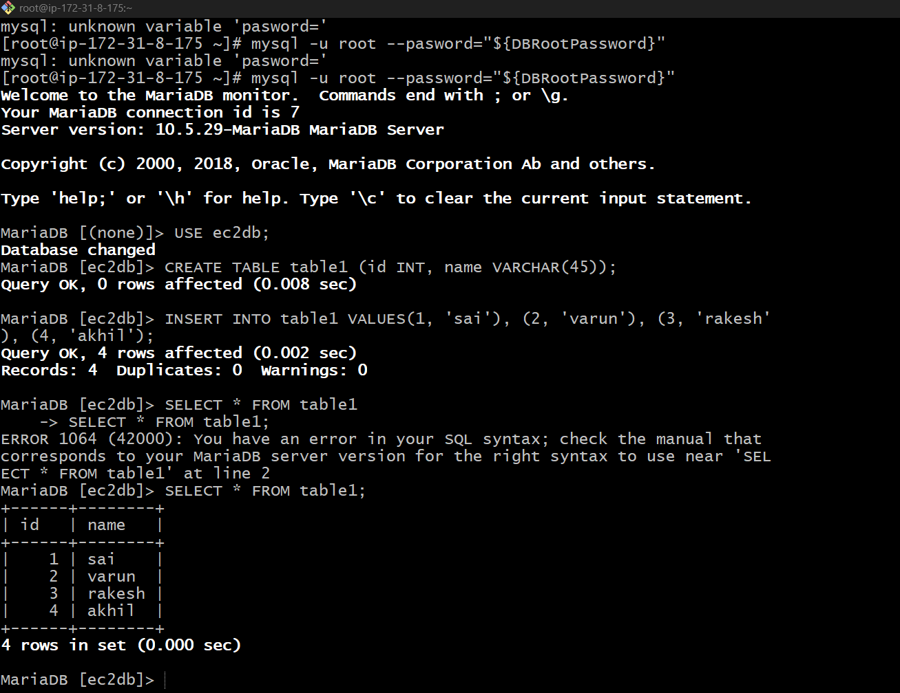

1. Take the backup of dummy data on EC2.

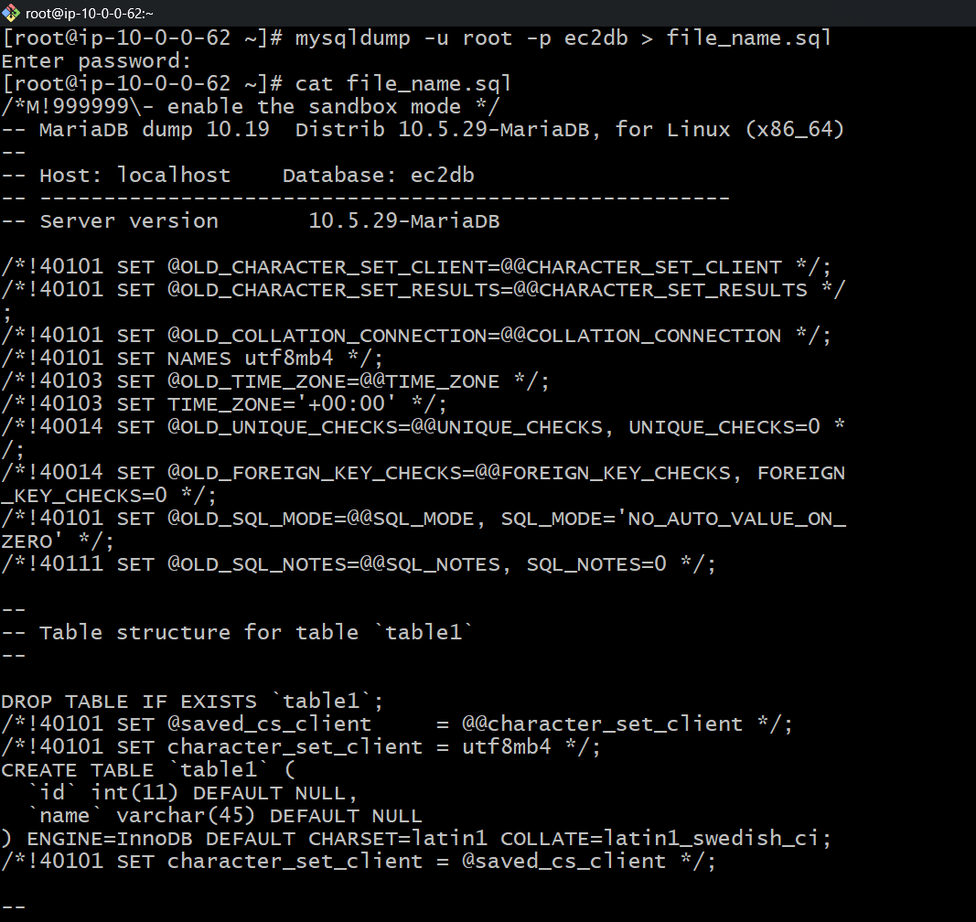

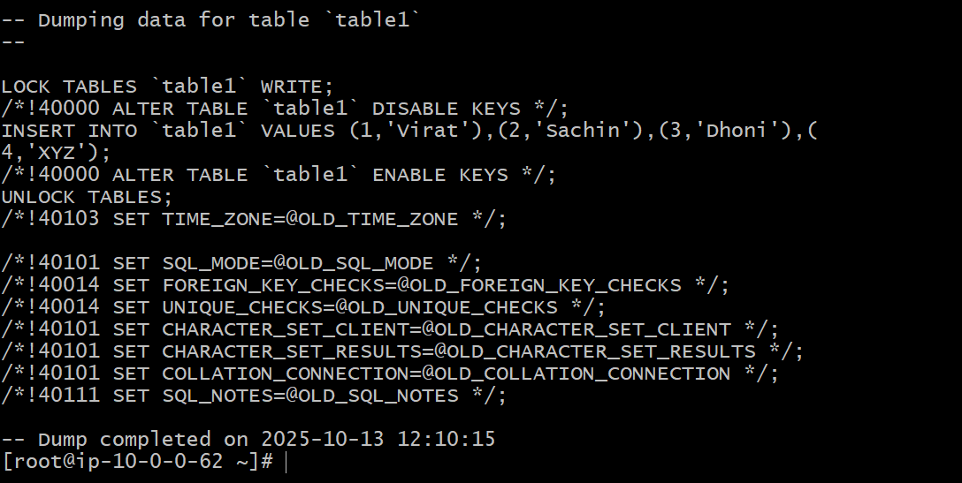

1. Launch MariaDB RDS instance.

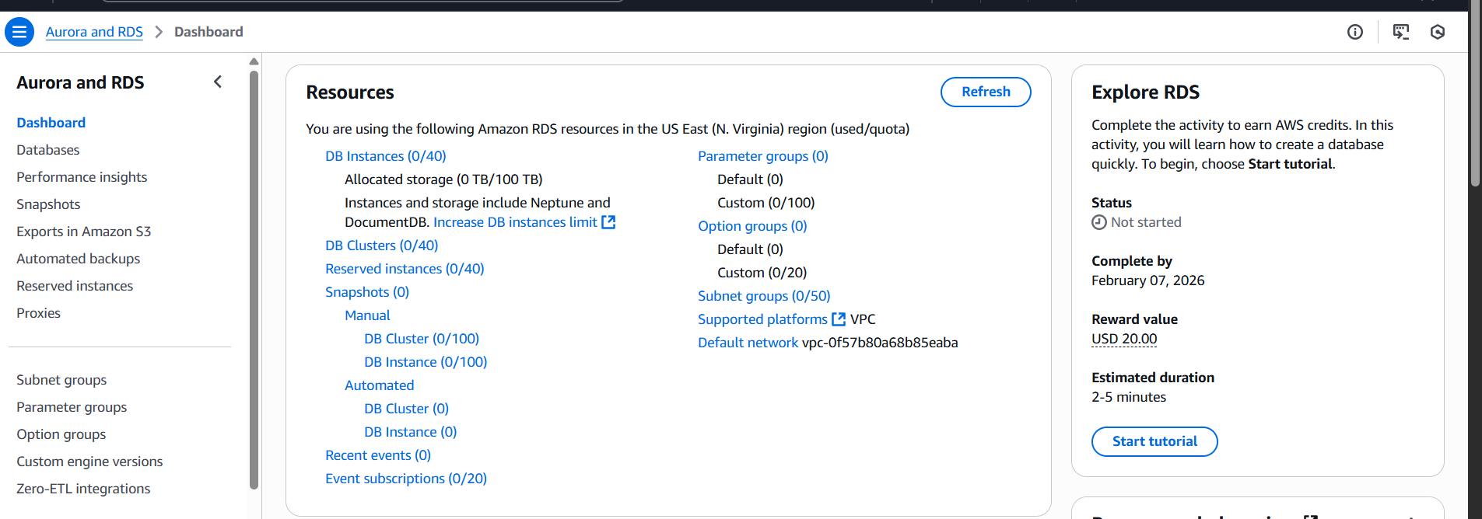

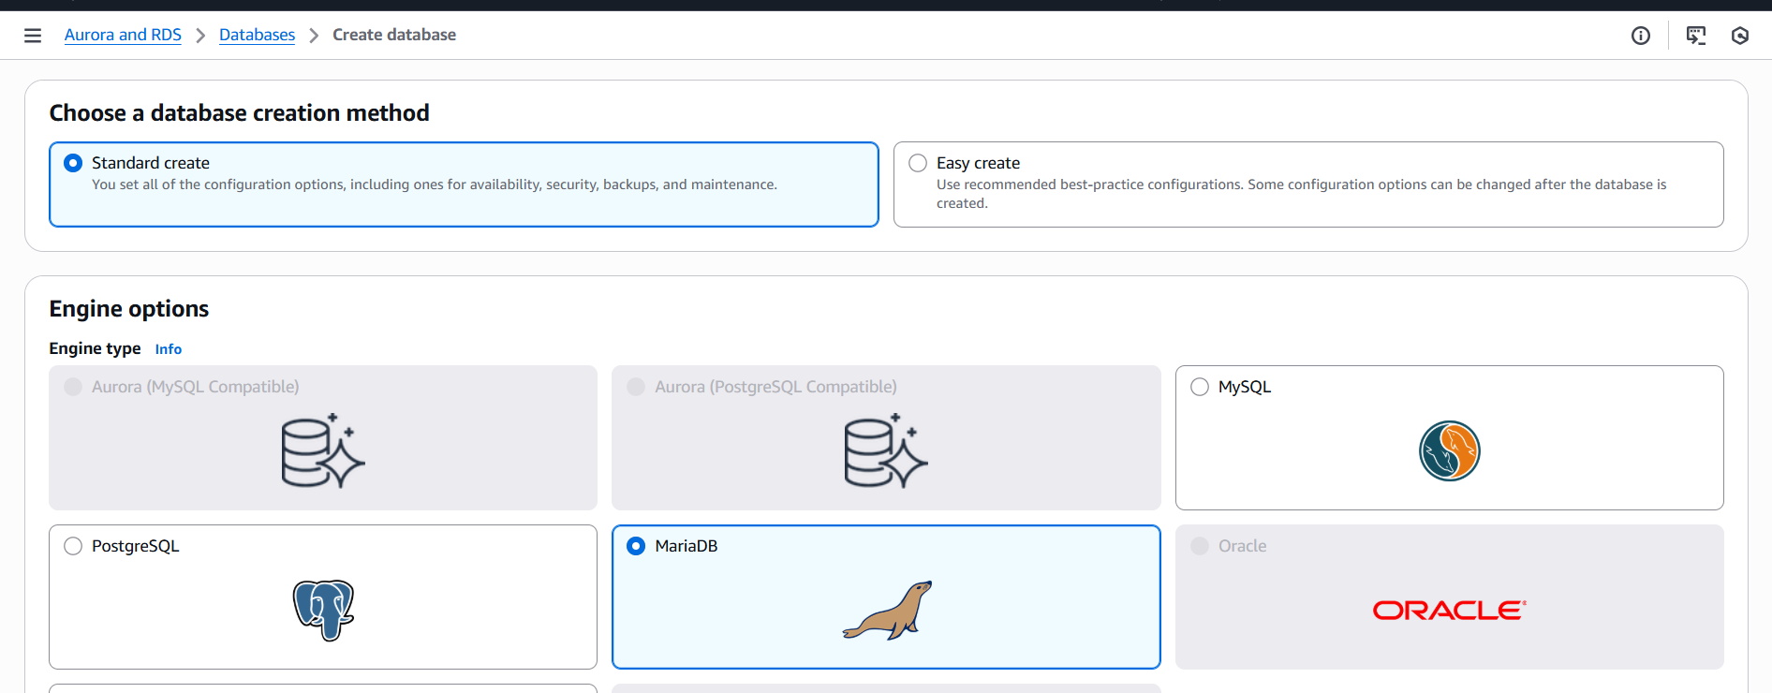

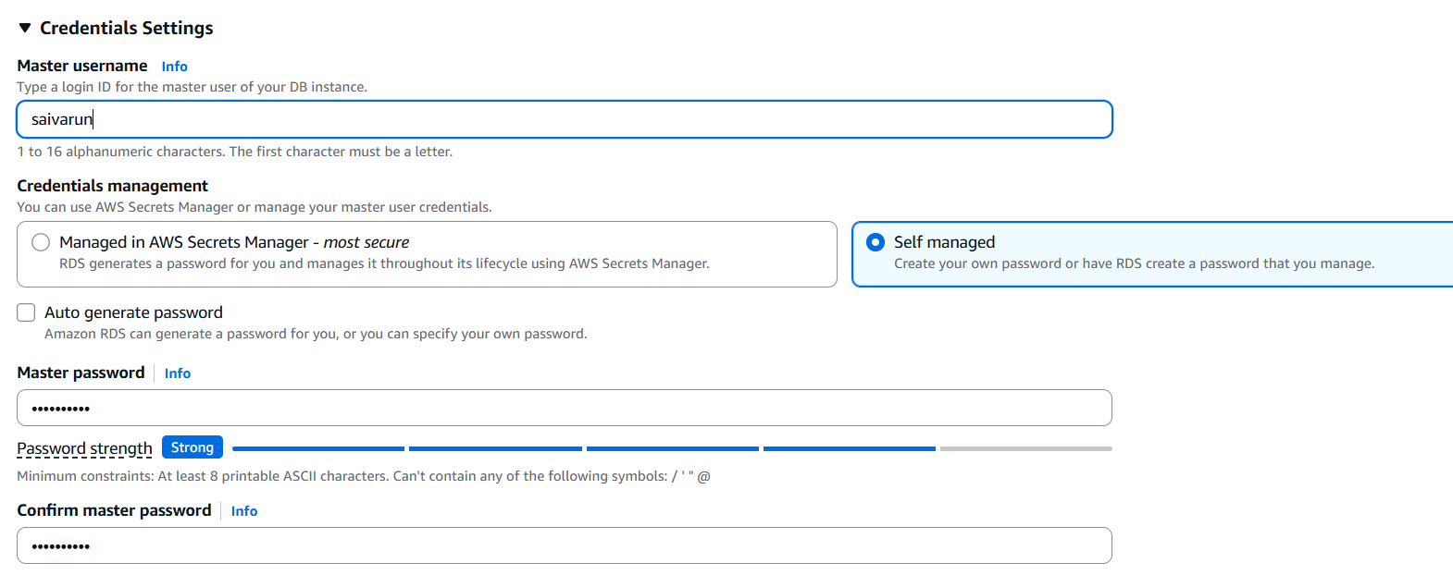

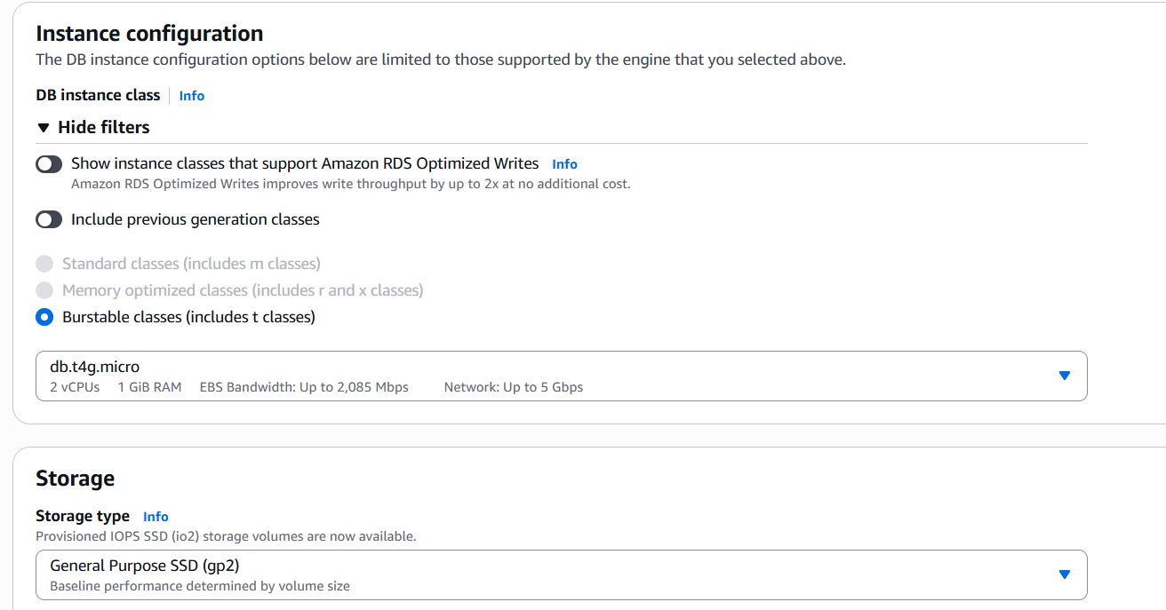

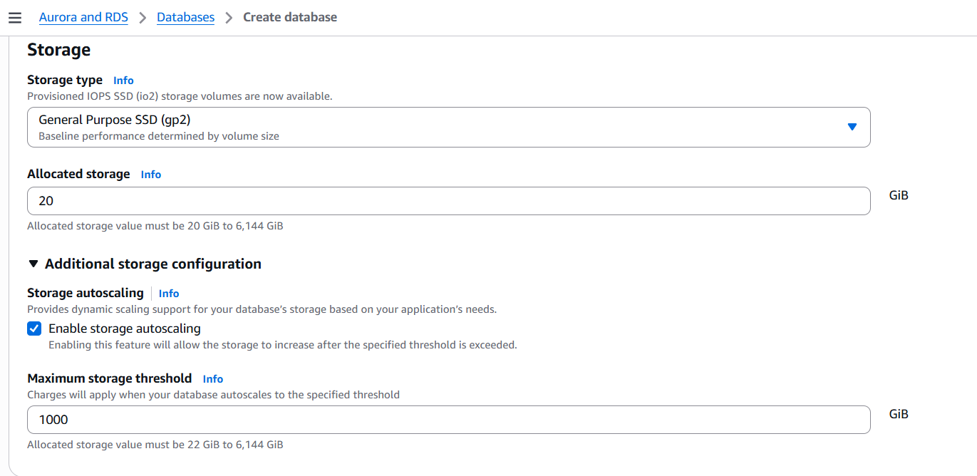

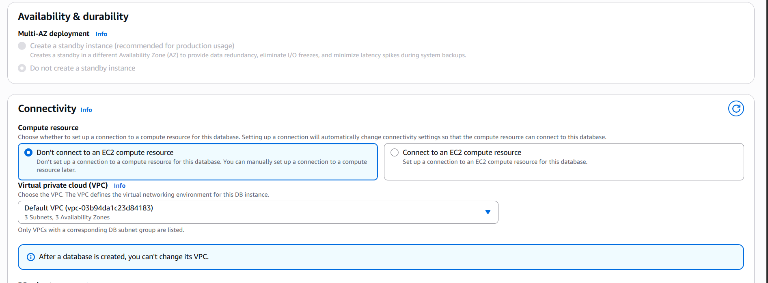

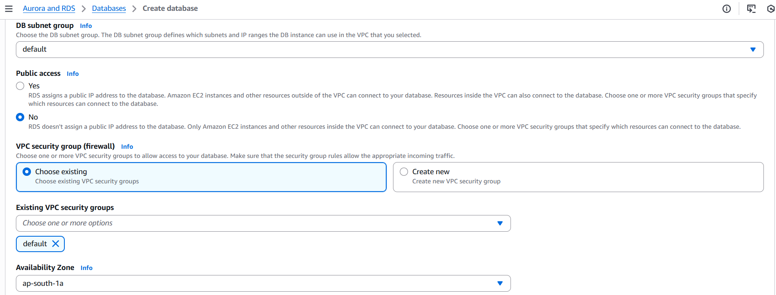

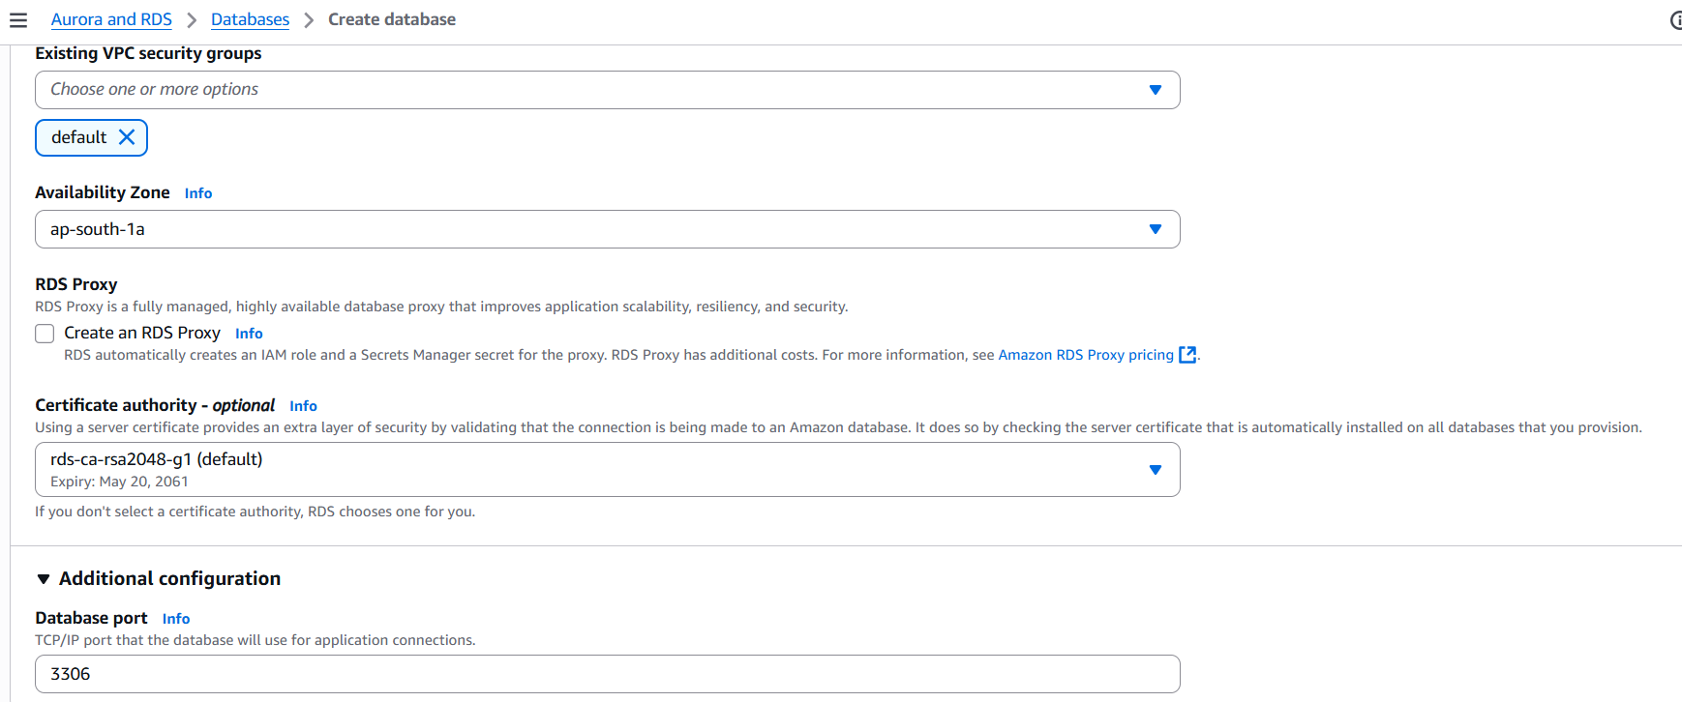

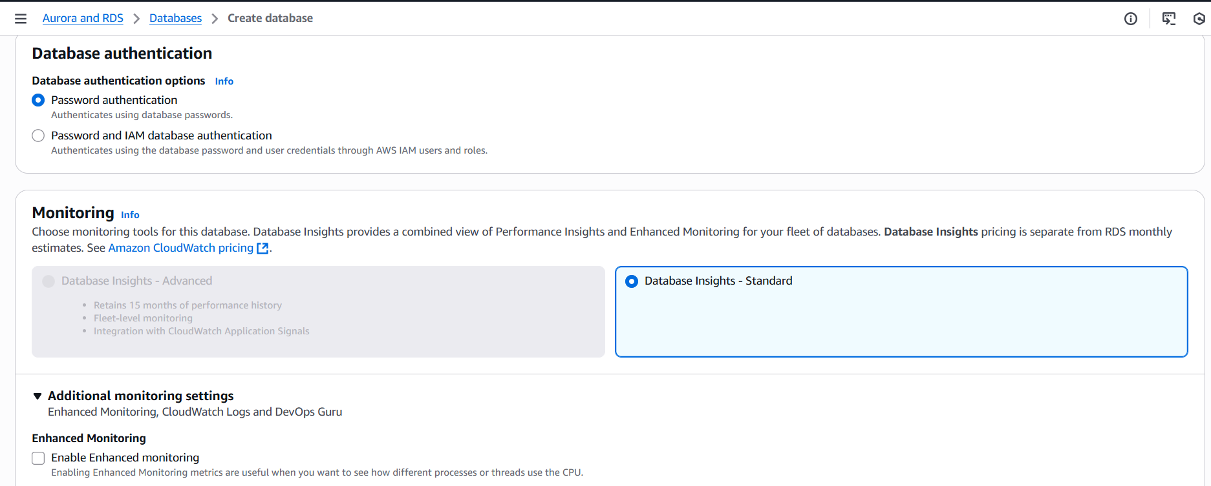

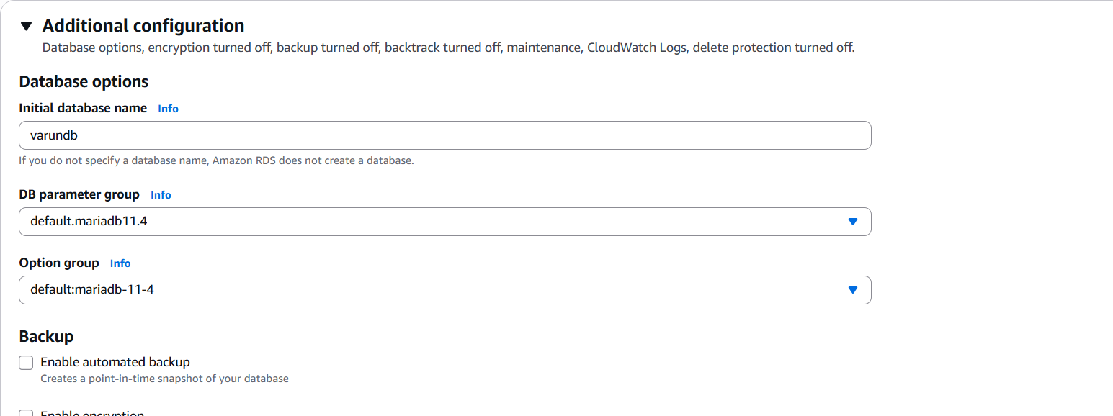

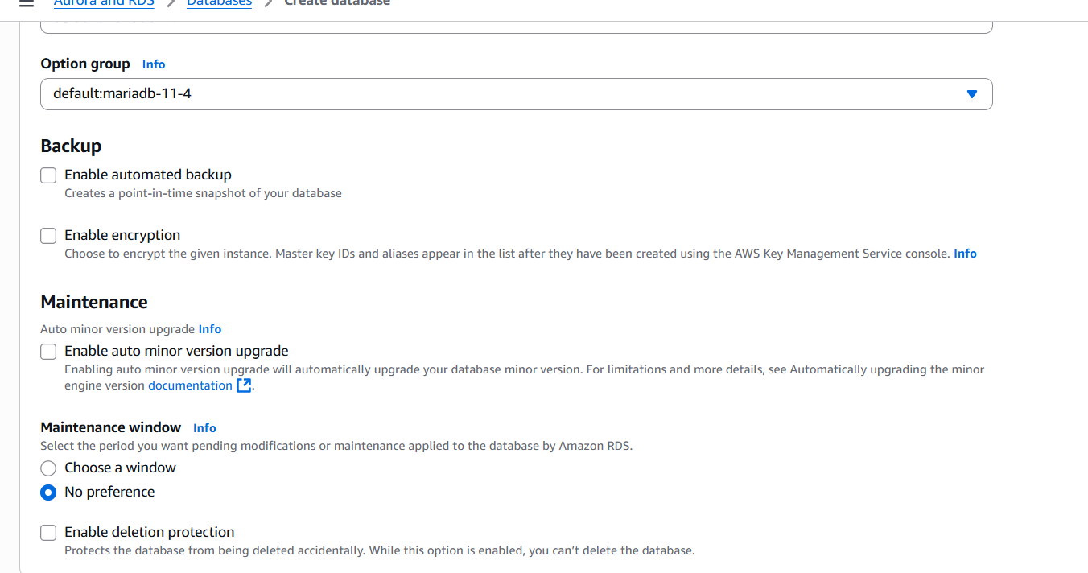

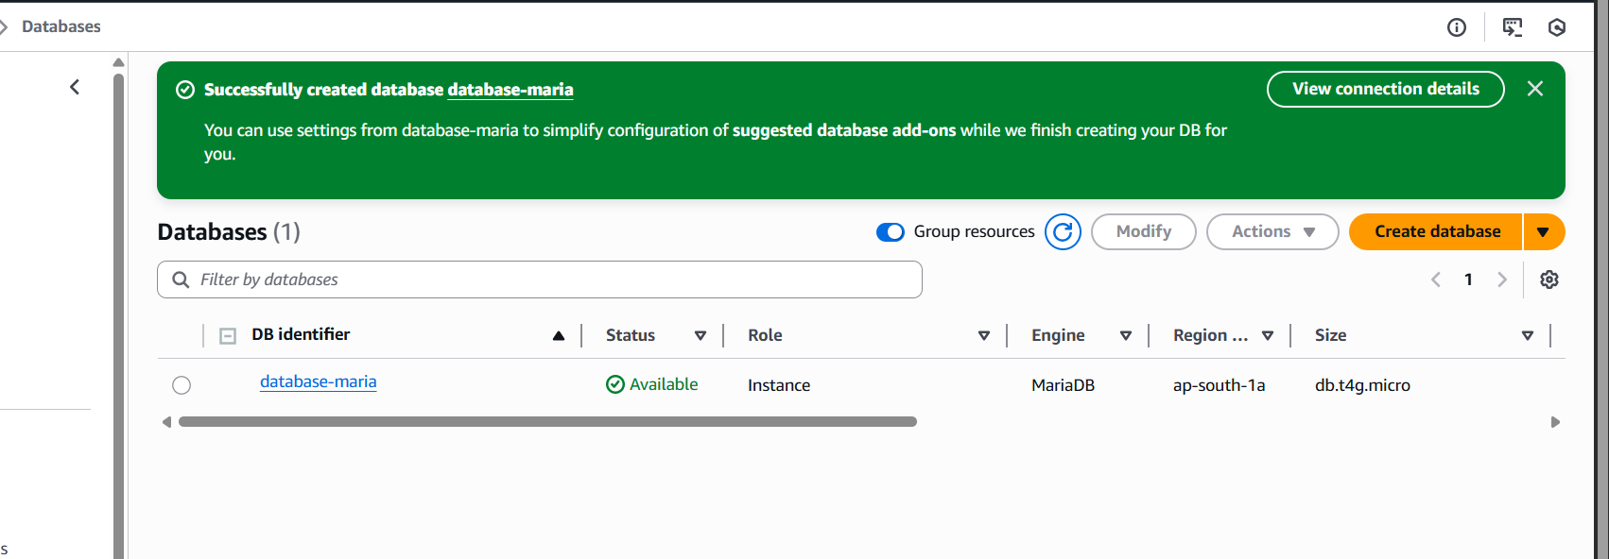

1. Migrate database from EC2 to RDS.

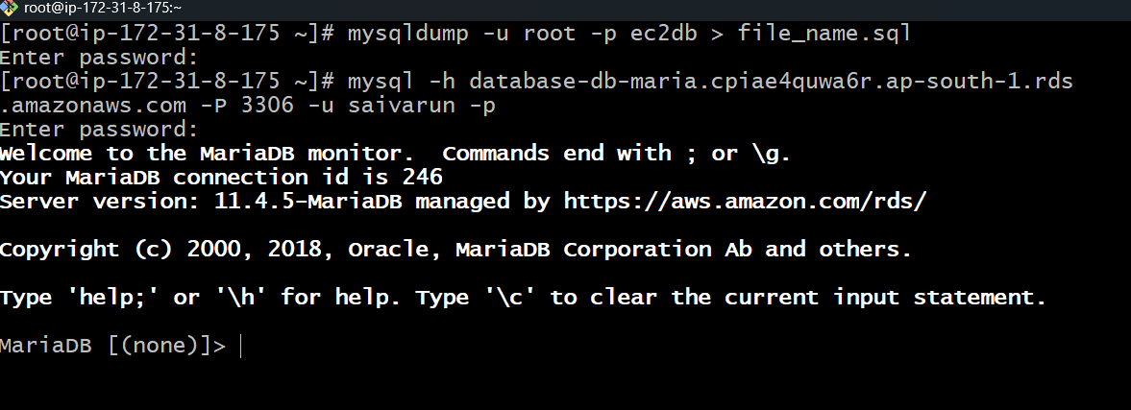

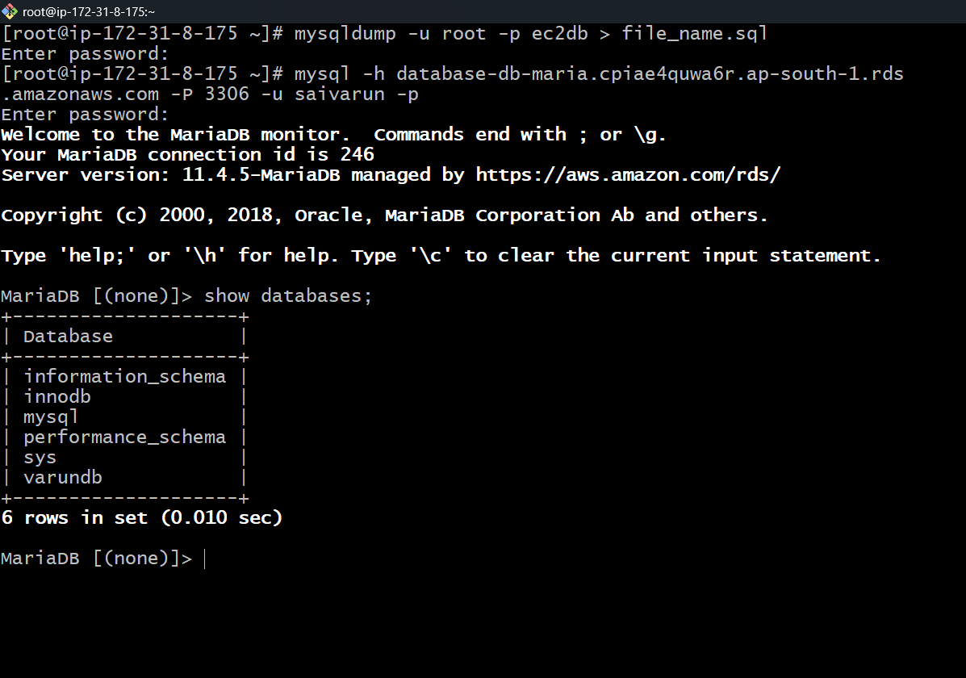

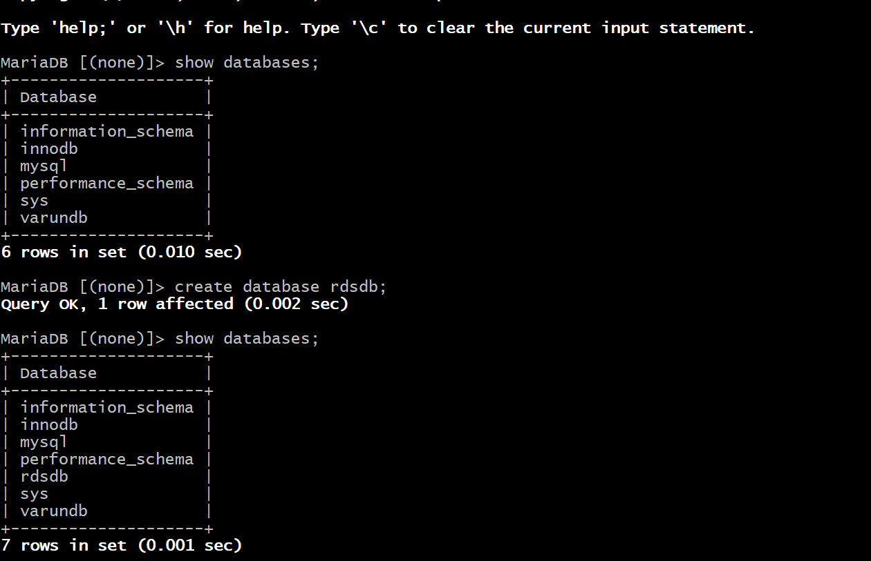

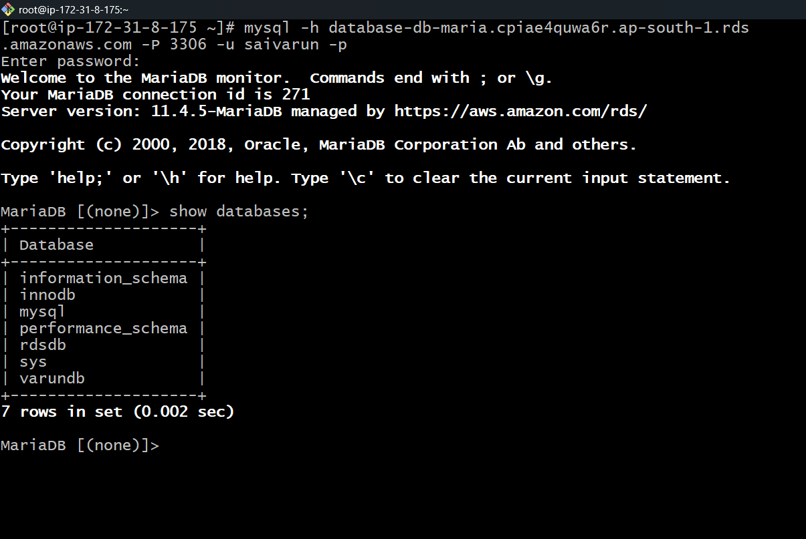

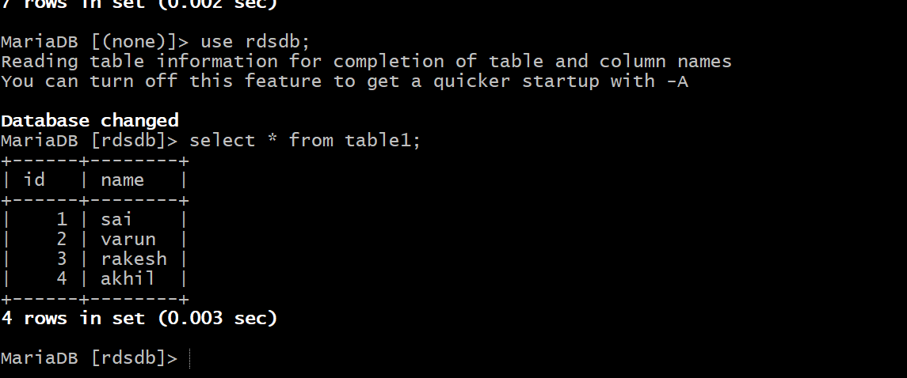

1. Install MySQL DB on EC2.

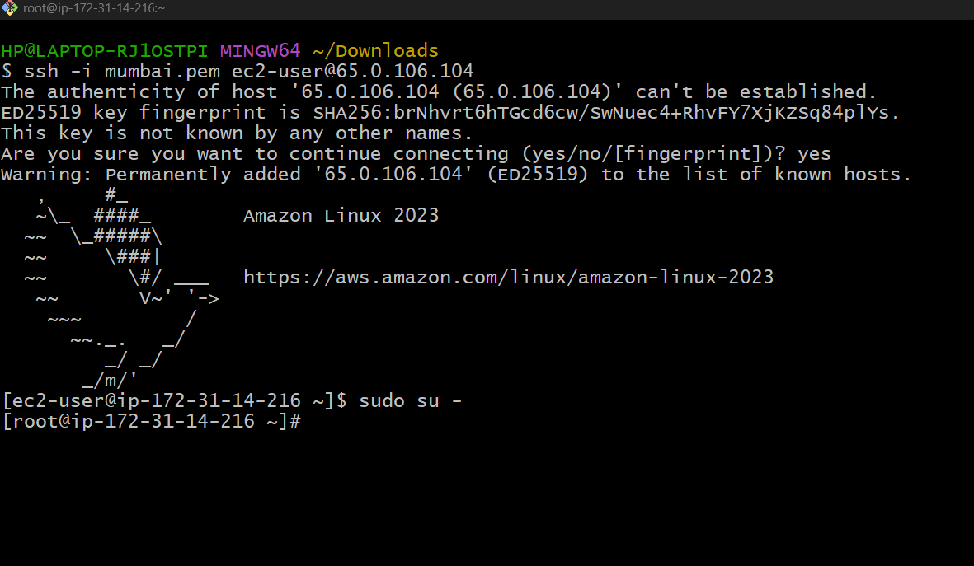

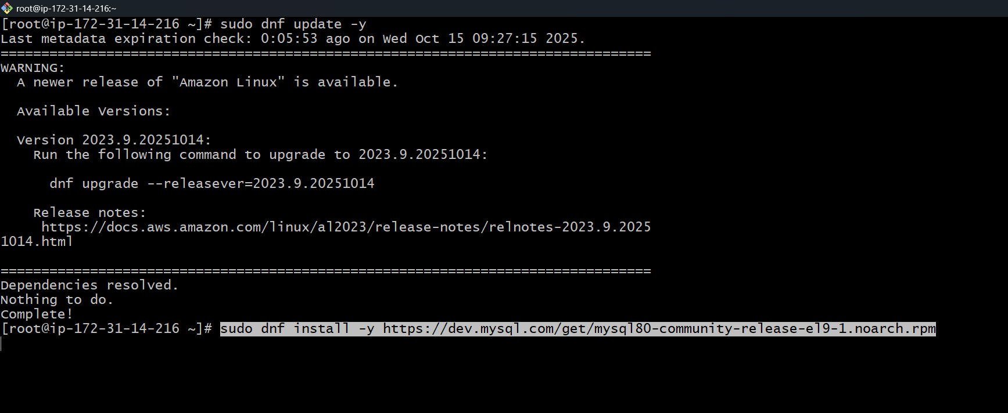

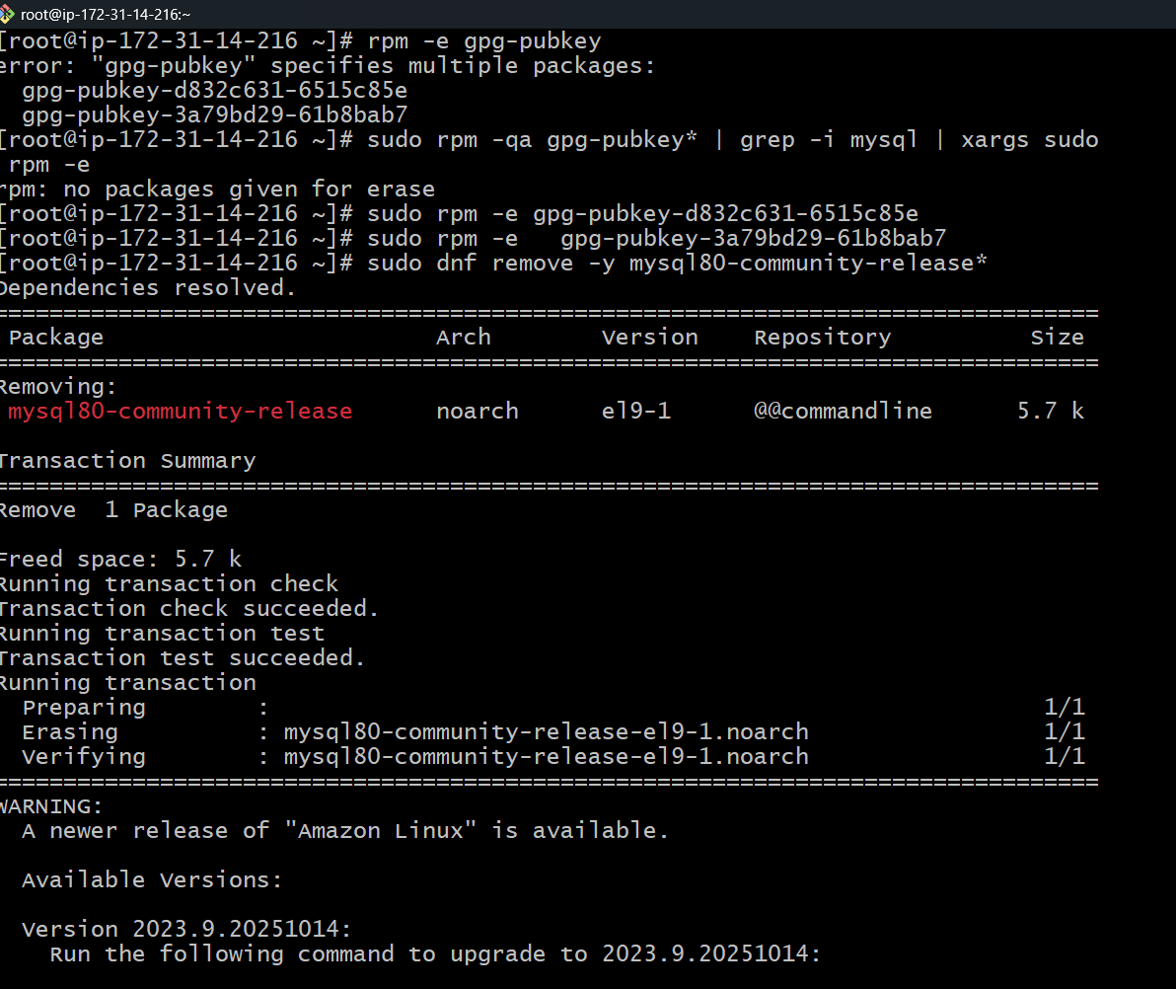

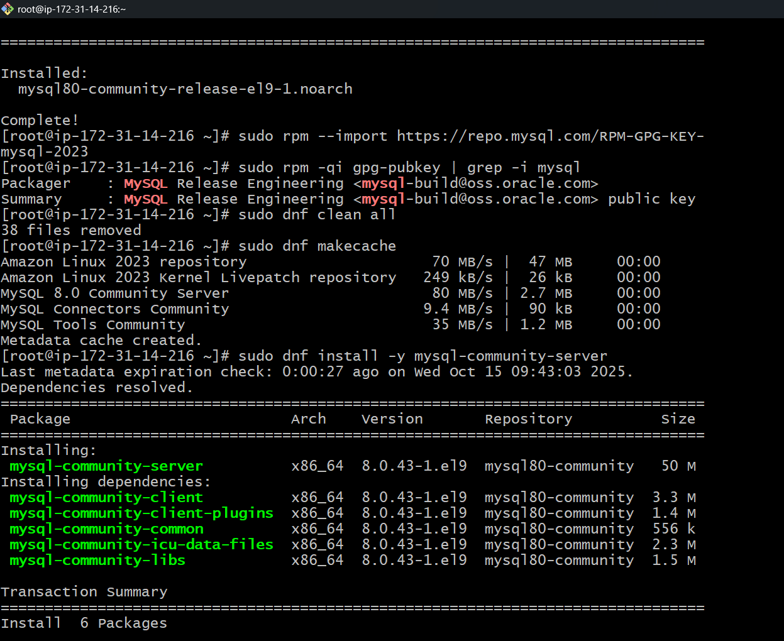

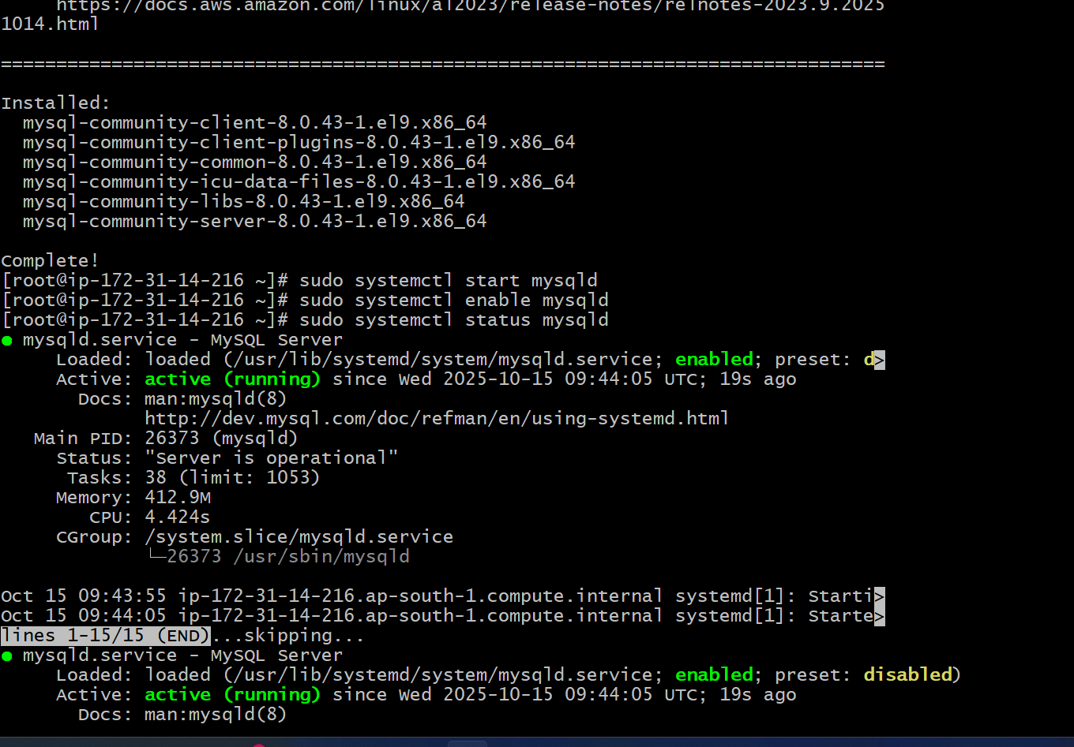

sudo rpm -e gpg-pubkey-<keyid>

sudo dnf remove -y mysql80-community-release\*

sudo dnf install -y <https://repo.mysql.com/mysql80-community-release-el9-1.noarch.rpm>

sudo rpm --import <https://repo.mysql.com/RPM-GPG-KEY-mysql-2023>

sudo rpm -qi gpg-pubkey | grep -i mysql

sudo dnf clean all

sudo dnf makecache

sudo dnf install -y mysql-community-server

sudo systemctl start mysqld

sudo systemctl enable mysqld

sudo systemctl status mysqld

1. Launch MySQL RDS image.

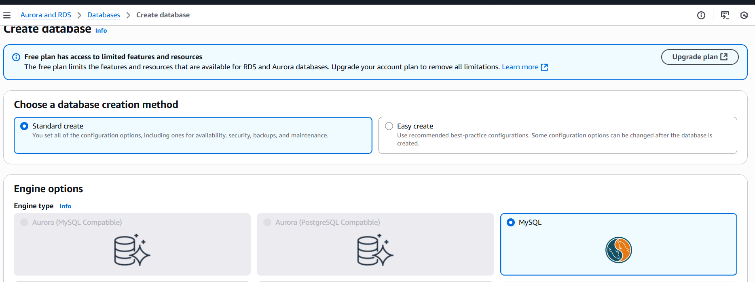

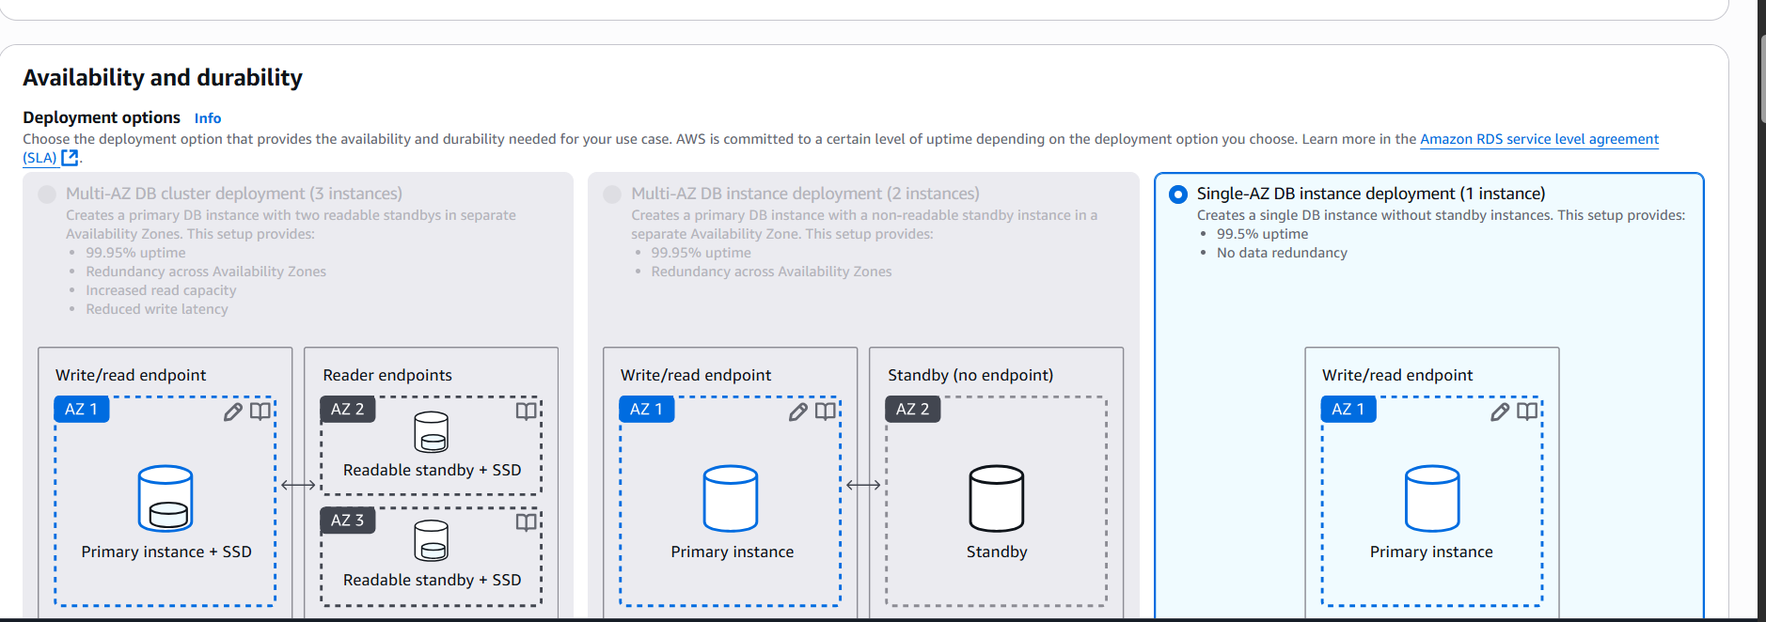

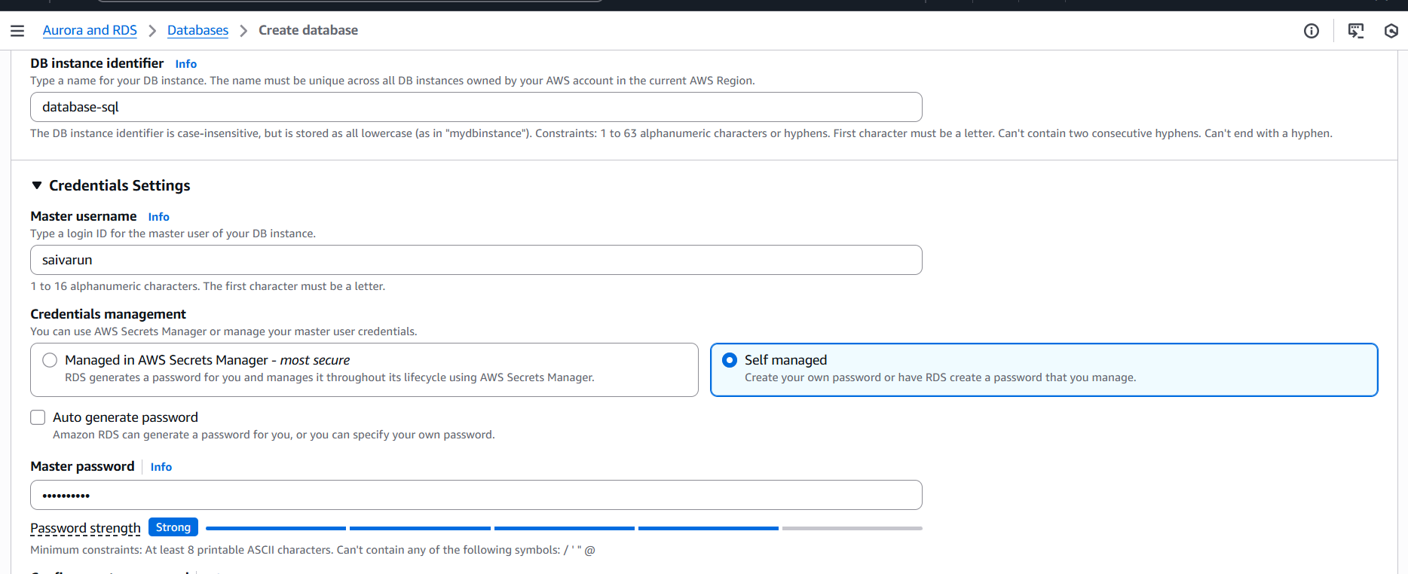

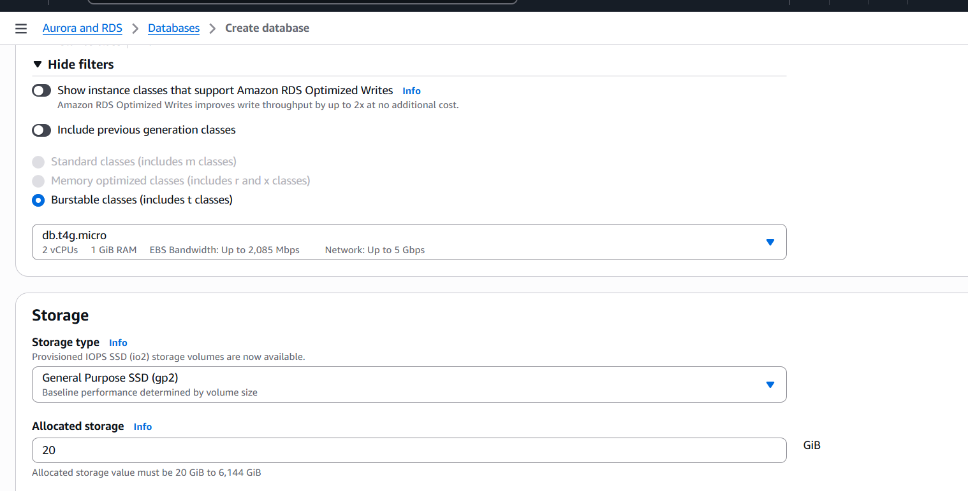

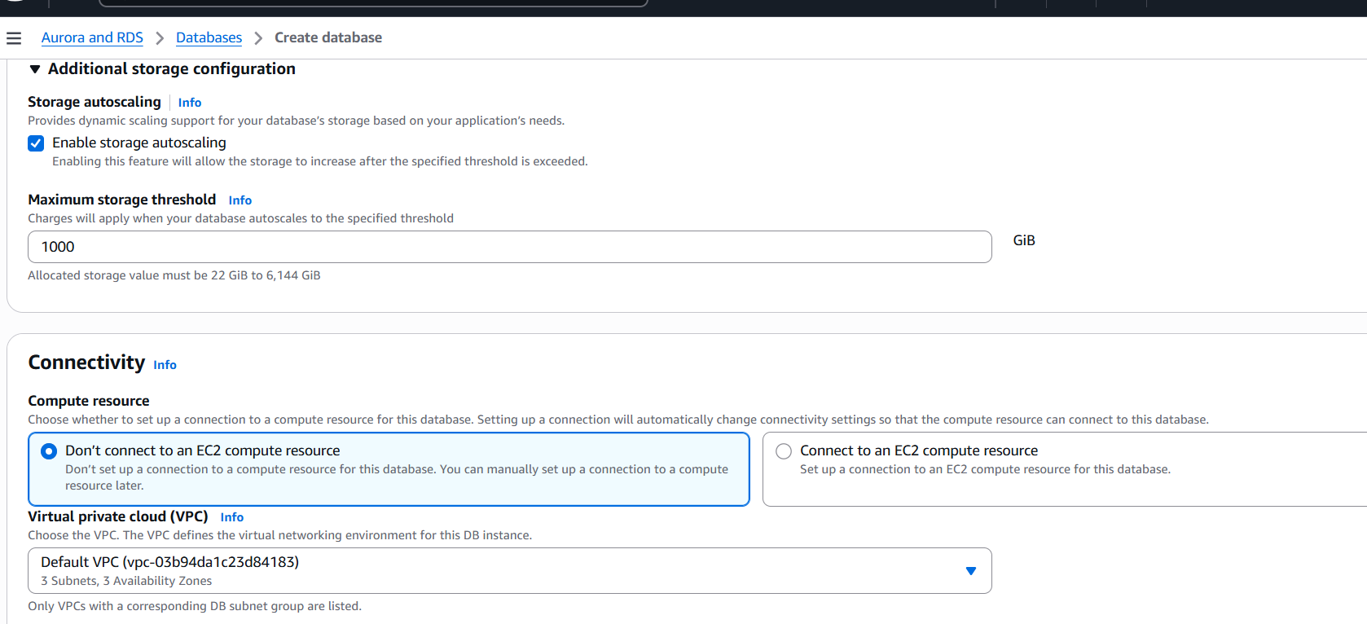

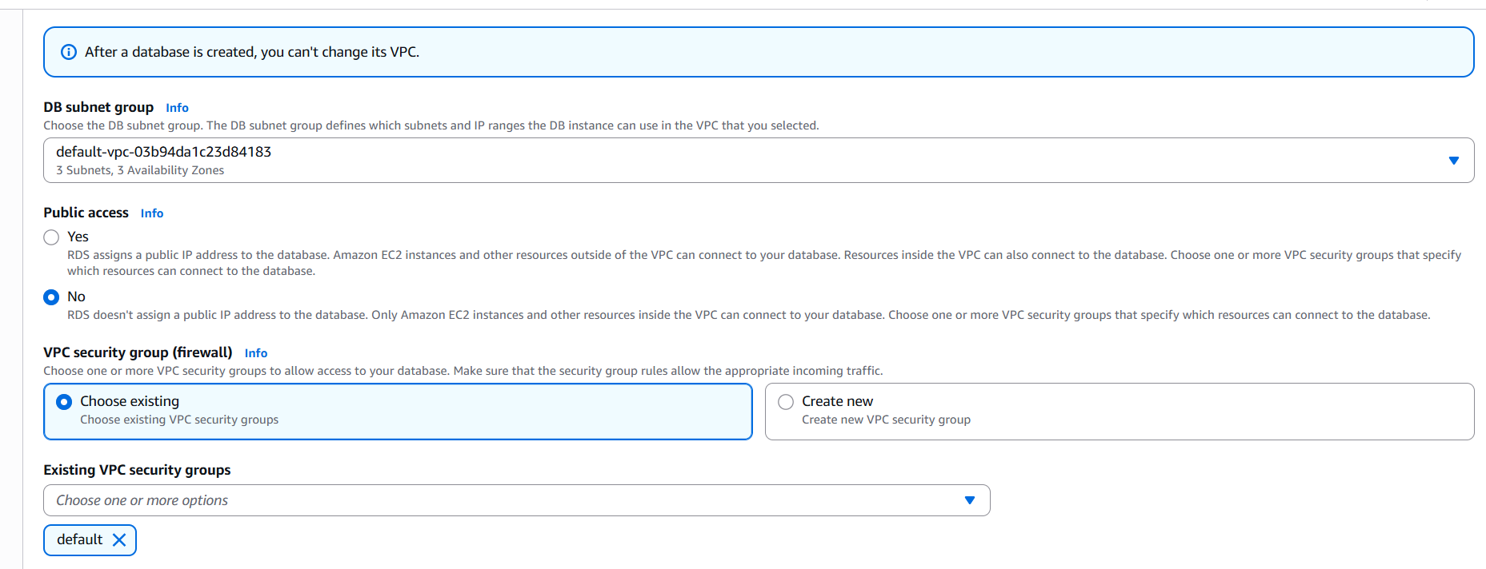

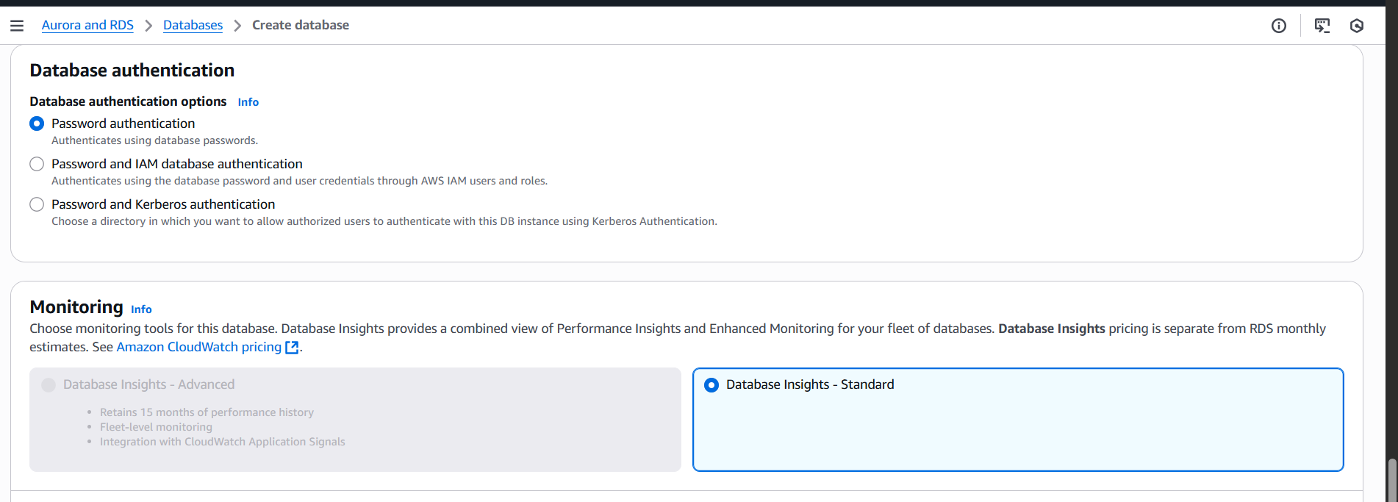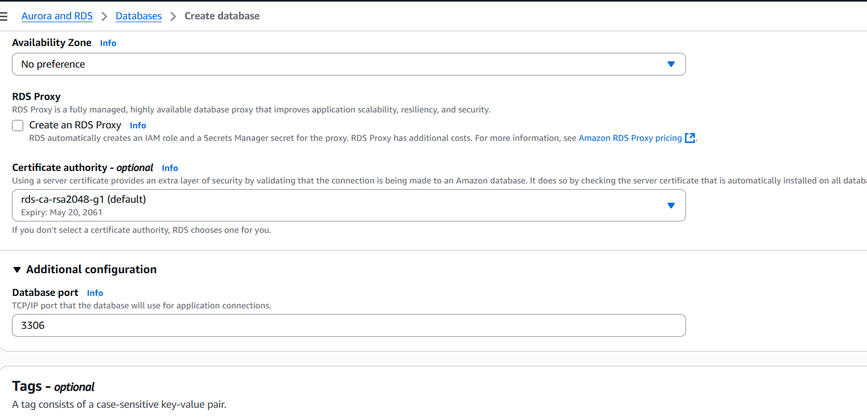

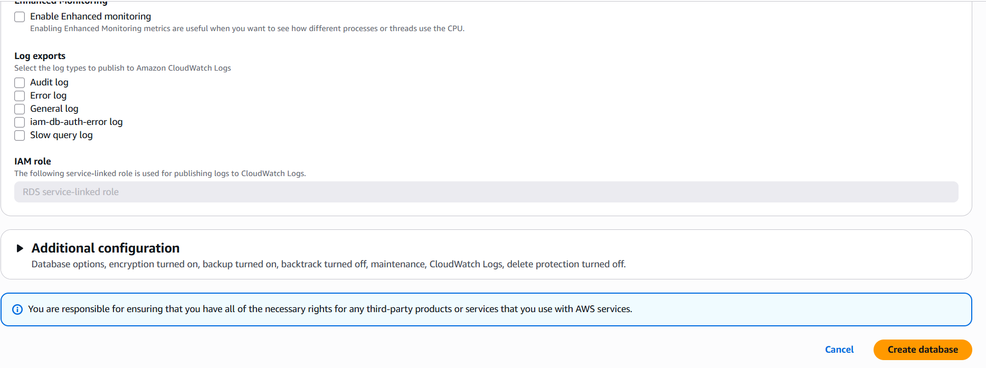

1. Configure Multi-AZ.

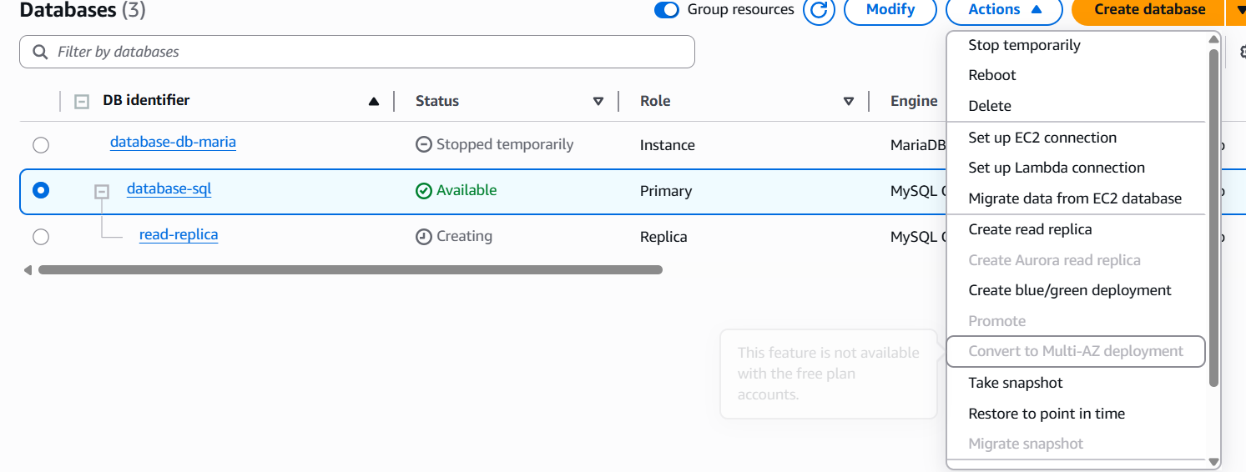

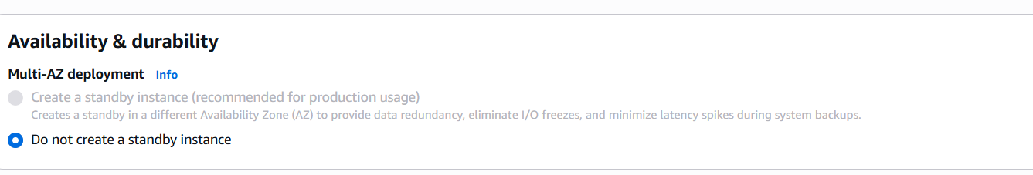

1. Take backup of DB and restore the DB.

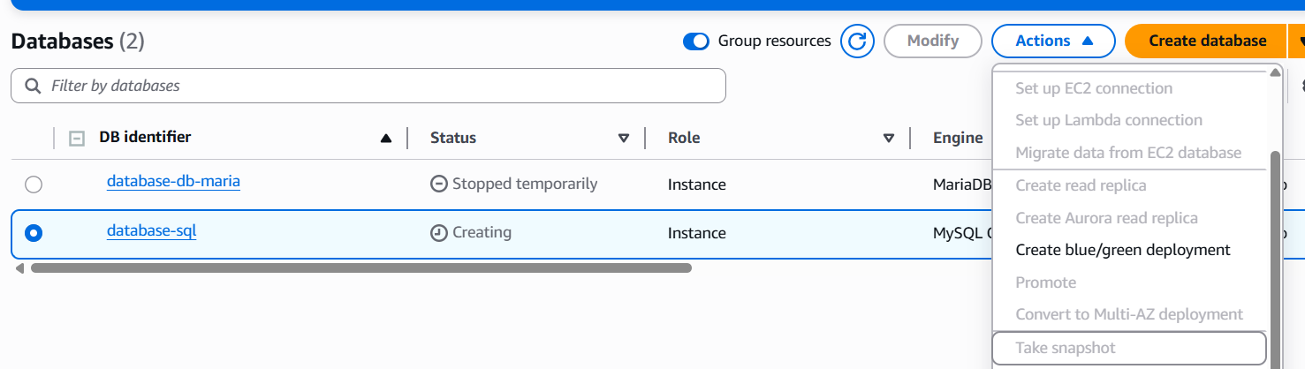

Step 1.Go to AWS Console → RDS.  
 In the left panel, click Databases.  
 Select your RDS Maria instance.  
 On the top right, click Actions → Take snapshot.  
 Enter a Snapshot name.  
Click Take snapshot

Step 2: Restore Database from Snapshot  
·Go to RDS → Snapshots.  
·Select the snapshot you created.  
·Click Actions → Restore snapshot

1. Create read replica.

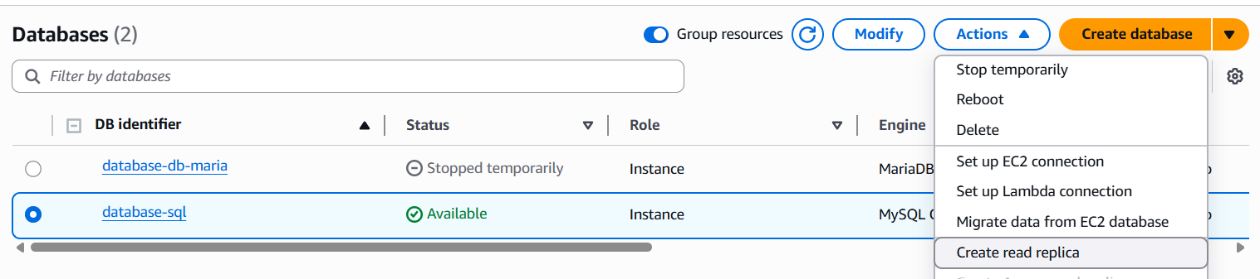

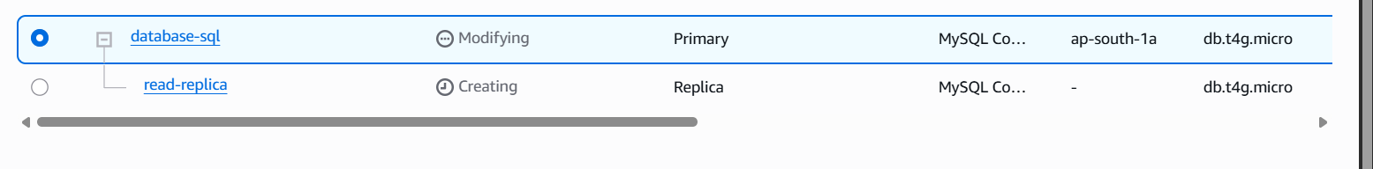

On the DB instance page,

click on the database

Actions → Create read replica.

Configure the read replica:

DB instance identifier: e.g., mysql-db-read-replica.

DB instance class: Choose based on your workload.

VPC, Subnet, Security Group: Must match or allow access from your

app.

Storage type: Same as primary (recommended).

Enable replication features: leave defaults unless specific use case.

Click Create read replica